**Hive**

**Screen Sketches**

TC_03 - Cameron Smith, Julie Van Kirk, Catherine Larson, Young Ha

**Actors**

**Guest user** (user of app who has not created an account):

* Ability to view posts from public/protected hives that they are not members of (they cannot be members of any hives since they do not have an account)
* Ability to create a user account.
* Able to look at hives near their current location

**Normal user** (someone who has created an account):

* Ability to view posts from public/protected hives that they are not members of.
* Ability to view, create, and interact with posts for hives they are members of.
* Ability to edit and delete their own posts that they created for any of their hives.
* Able to look at hives near their current location
* Ability to create, request to join (if protected), and join (if public or invited to private) hives.

**Hive moderator** (normal user but has created a hive (group chat/forum) from scratch or was added to list of moderators by another moderator)

* All rights that a normal user has.
* Ability to edit the list of moderators for their hive that they are moderators for.
* Ability to edit any attributes of the hive (name, description, coordinates, interests… etc.)
* Ability to accept requests that users send to them if the hive they are moderator for is protected (users must request to join, public hives anyone can join).
* Ability to delete posts in the hive that they are moderators for.

**NonFunctional Requirements (Step 3)**

1. Performance

2. Scalability

3. Security

**Tables**

**comments:**

| comment_id | post_id | user_id | date_created | text_content |
| --- | --- | --- | --- | --- |

**hives:**

| hive_id | date_created | name | description | type | coords |
| --- | --- | --- | --- | --- | --- |

**likes:**

| post_id | user_id | date_created |
| --- | --- | --- |

**members:**

| hive_id | user_id | date_created | is_moderator |
| --- | --- | --- | --- |

**posts:**

| post_id | hive_id | user_id | date_created | title | text_content |
| --- | --- | --- | --- | --- | --- |

**users:**

| user_id | date_created | user_name | display_name | birthday | biography |
| --- | --- | --- | --- | --- | --- |

**requests:**

| hive_id | user_id | text_content |
| --- | --- | --- |

**registrations:**

| user_id | user_email | user_password |
| --- | --- | --- |

| **interests:**   | interest_id | interest_text | | --- | --- | | **hive_interests:**   | hive_id | interest_id | | --- | --- | |
| --- | --- | --- | --- | --- | --- |

**Screen Flow**

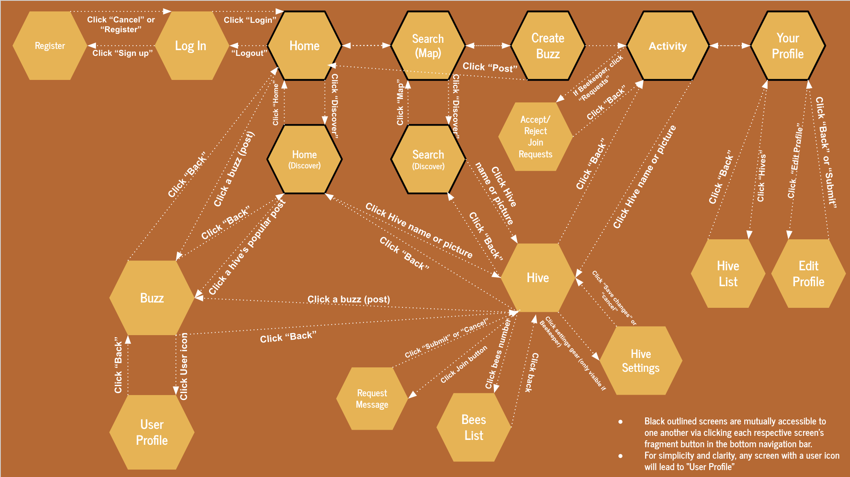

**Cameron Smith - Screen Sketch 1: Hive View**

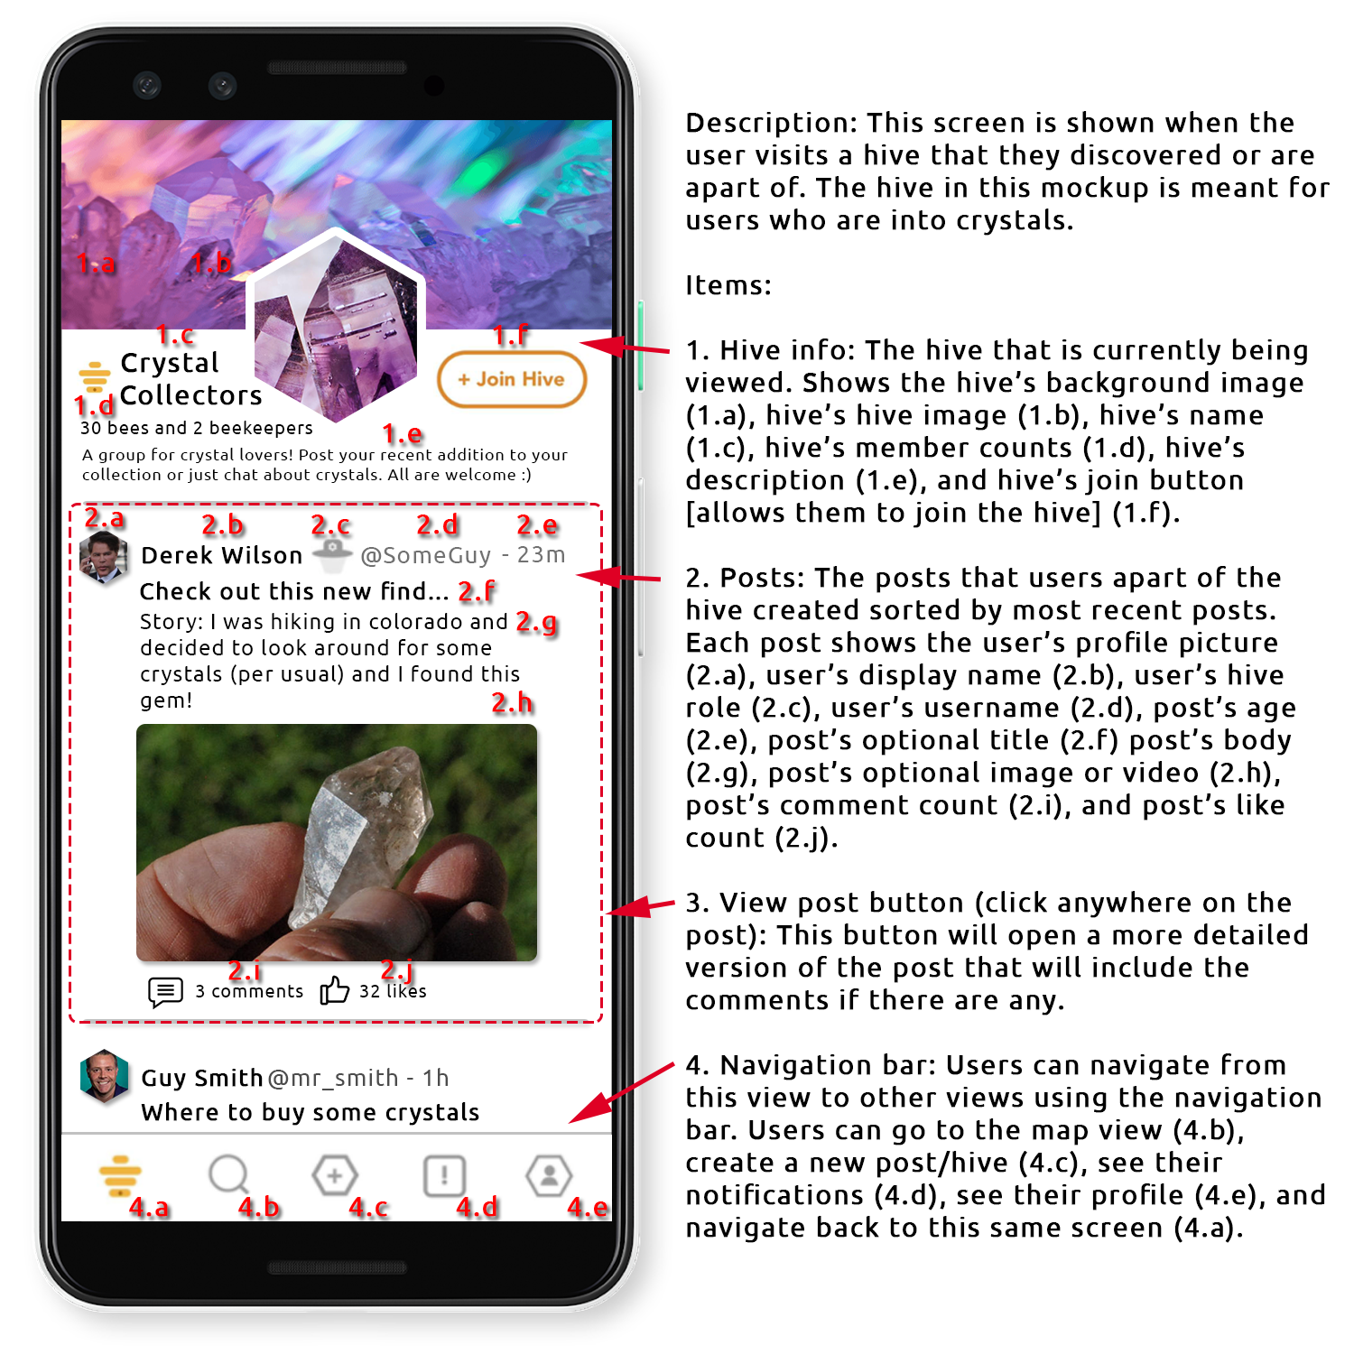

**Cameron Smith - Screen Sketch 2: Post View**

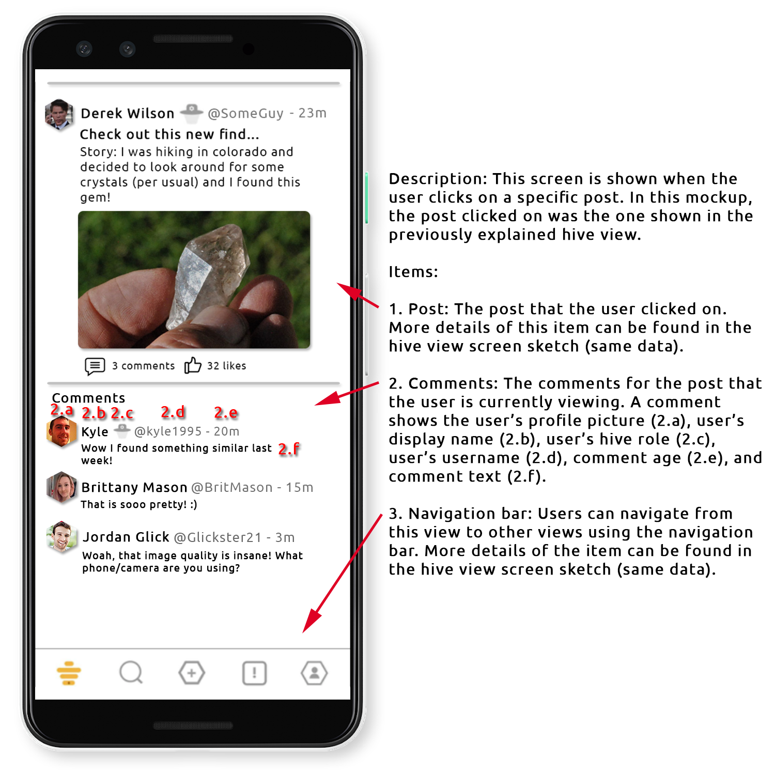

**Julie Van Kirk - Screen Sketch 1: Discover List View**

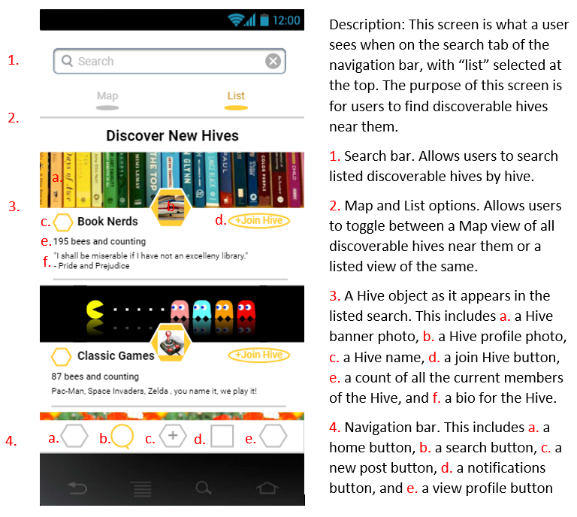

**Julie Van Kirk - Screen Sketch 2: Notifications/Activity View**

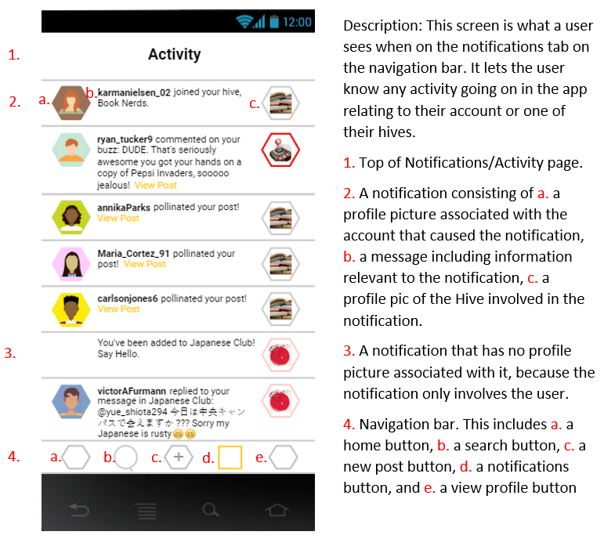

**Catherine Larson - Screen Sketch 1: Discover Map View**

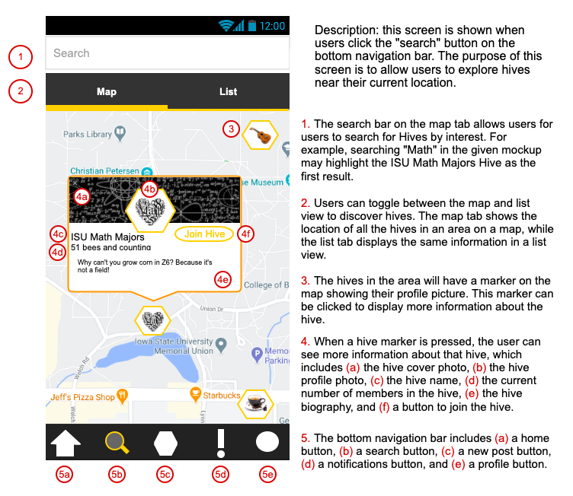

**Catherine Larson - Screen Sketch 2: Home feed**

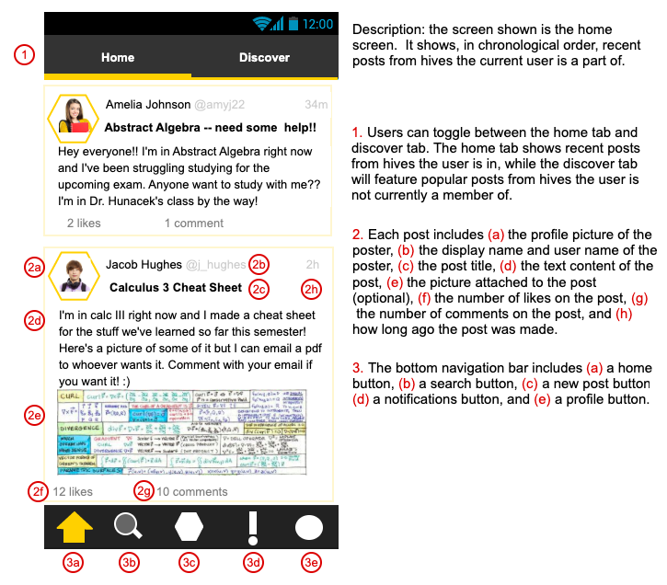

**Young Ha - Screen Sketch 1 - Activity**

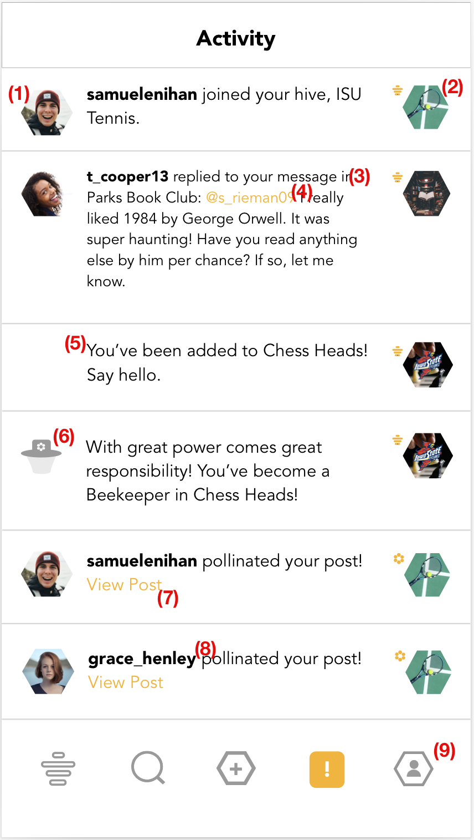

The activity fragment should display all of the “buzz” in the hives of any given user. Each row displays a unique buzz, and if it came from another user, a profile photo will be displayed (1) alongside the respective hive’s photo (2). Another example (2) of a buzz might be if someone replied to your message or mentioned you as a user, if this occurs, your username will glow yellow (4) and will be clickable. You might also be added to another hive (5) that was protected or private and needed to be manually accepted by a beekeeper -- which if you’ve become one of a certain hive, you will be notified as well (6). There will be a clickable hyperlink to a post if someone pollinates it (7) and you can view the user who pollinated your post by clicking on either their photo or username (8). You may navigate away to other fragments using the navigation bar at the bottom of the screen (9).

**Young Ha - Screen Sketch 2 - Profile**

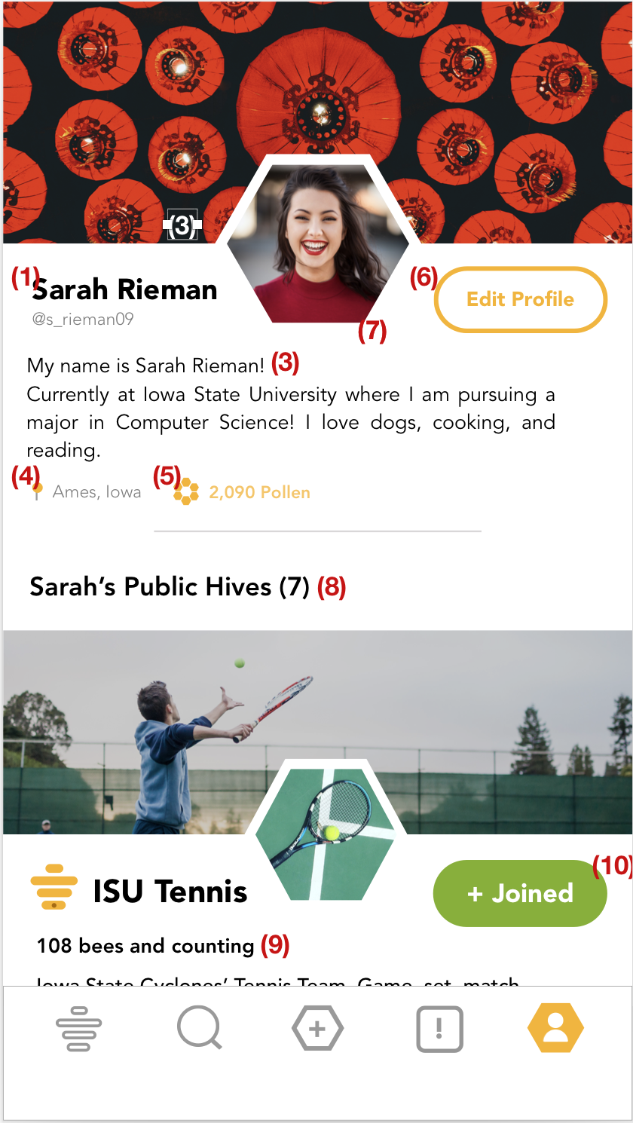

A profile should be a superficial display of who is behind any given user. Hive celebrates community, but doesn’t want to necessarily eliminate individuality. We’ve designed a user’s profile to include a custom header and profile image (3 + 4).

We’ve also configured the fragment to display formatted text. A user’s display name (1) may be the same as another user, but their username must be unique. A user will also be able to write a short description about themselves (3), and can change that at any time. Optionally, they can provide a location (40 that will display next to their pollen count (5) -- which is a reflection of how many pollen points or “likes'' a user has. This will show how active a user is in their communities, which is listed in their Hive list (7). Each hive will have its respective count of members (9) and a button (10) that viewers of the profile can click to join if they aren’t already a part of that hive.